REV. | Description | Date
S00 | 102A-199075  增加ADP-65DW Y2G 與 ADP-65DW Y2E 做成系列 | 09/19’19
S01 | 102A-19A015  ADD ADP-65DW X2E/X2G/Z2E/Z2G MODEL NAME | 10/03‘19
00 | 102A-208075  ADD ADP-65DW ZZD MODEL NAME  MODIFY ITEM3.2/3.3/3.4 FOR 65DW ZZD  102A-208053  ADD ADP-65DW X2L /Y2L/Z2L/ X2M/Y2M/Z2M/MODEL NAME  Release mass production spec | 08/17‘20
01 | 102A-215078  ADD MODEL ADP-65DW X2R/Y2R/Z2R | 05/27‘21
02 | 102A-21A225  ADD MODEL ADP-65DW EBA/ZBA/WBA/YCA | 10/28‘21
03 | 102A-21C116  ADD MODEL ADP-65DW EBAEA/EBAEB/EBAEC/ EBAED/EBAEE | 12/17‘21
04 | 102A-225021  ADD MODEL ADP-65DW EBAEF | 05/10‘22
05 | 102A-225145  ADD MODEL ADP-65DW Y2S,Y2T,X2S,X2T,Z2S,Z2T | 05/19‘22
06 | 102A-232059  ADD MODEL NAME: ADP-65DW X2E5/X2L5/Y2E5/Y2L5  Add Model list and Item3 (3.2) (3.5) for new model. | 02/14‘23
07 | 102A-244019  ADD MODEL ADP-65DW ZBB  102A-244020  ADD MODEL ADP-65DW ZBC | 04/08‘24

MODEL LIST
MODEL NAME | TYPE
ADP-65DW Y2E/Y2G/Y2L/Y2M/Y2R/YCA/Y2S/Y2T/Y2E5/Y2L5 | US
ADP-65DW X2E/X2G/X2L/X2M/X2R/X2S/X2T/ X2E5/ X2L5 | CN
ADP-65DW Z2E/Z2G/Z2L/Z2M/ZZD/Z2R/ZBA/Z2S/Z2T/ZBB/ZBC | EU
ADP-65DW EBA/EBAEA/EBAEB/EBAEC/ EBAED/EBAEE/EBAEF | AU
ADP-65DW WBA | UK

- ELECTRICAL
  - Input Characteristics:
    - Nominal Voltage
It is normal for 100 ~ 240Vac input AC voltage.
    - Input Voltage Range
The Adapter shall operate from 90 ~ 264Vac.
    - Rated Frequency
It is normal for 50Hz or 60Hz and single phase.
    - Frequency Range
The Adapter shall operate with an input frequency from 47 Hz to 63 Hz.
    - Input Current
1.5A Max at 100Vac input voltage.
    - Inrush Current Limit (cold start)
The I²t shall less then 22% of the Fuse.
    - Efficiency (Warm Up)
      - 86.0 % min. at nominal input voltage, maximum load and measured at the end of DC cable. (Warm up )

      - Active mode efficiency:
More than 88% of average efficiency of 25%,50%,75% and 100% load tested at 115Vac/60Hz and 230Vac/50Hz.(Warm up after 30min)
      - The efficiency at 10% loading shall be more than 79% measure at 115Vac/60Hz and 230Vac/50Hz.
    - No Load Power Consumption
Maximum non-load power consumption is less than 0.21W at 115Vac/60Hz and 230Vac/50Hz
    - Power saving requirement
115Vac/60Hz, 230Vac/50Hz.
DC POWER(W) | AC Spec. Power ( W )
18.0 | <21
11.0 | <14
3 | <5
1.65 | <3
1.5 | <2.2
1 | <1.6
0.25 | <0.45
  - Output Characteristics:
    - Rated Voltage
The rated output voltage is specified at 19V.
    - Voltage Range
The output voltage will be performed 18.5V~20.5V when the load is 0A ~ 3.42A steadily.
    - Current
This Adapter can work from 0 A to 3.42A and output voltage is in section 1.2.2 specified range.
    - Output Ripple and Noise
Output ripple voltage is 300 mV peak to peak. AMB : 25deg-C
Measured methods:
T1. Performed by 20M Hz bandwidth in oscilloscope.
T2. Applied 0.1uF high frequency capacitor and 10uF electrolytic capacitor across output connector terminals.
T3. Measured at the end of DC cable.
T4. 47Hz and 63Hz tested at 90Vac and 264Vac.

    - Turn On delay time
The Adapter shall switch on in less than 3 seconds at input voltage is 100Vac~240Vac.
    - Hold –up time
The output voltage shall be sustained 5mS within regulation requirement after loss 100Vac and maximum load.
    - Rise time
DC output rise time from 10% to 90% of output voltage shall be less than 40mS at nominal lineand maximum load.
    - Overshoot
The output overshoot at turn on shall not exceed 5% of normal voltage value with or without the load connected.
    - Peak load
The adapter shall support below loading condition without and damage, safety issues and protection happen. The output voltage shall more than 17V at input voltage is 100-240Vac/50Hz in 25℃.

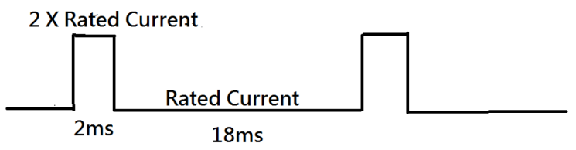
    - Surge load:
The adapter shall support a surge load with 120% of maximum load for 1min , maximum load for 9min and Output Voltage more than 18.0V at input voltage is 100-240Vac in 25℃.

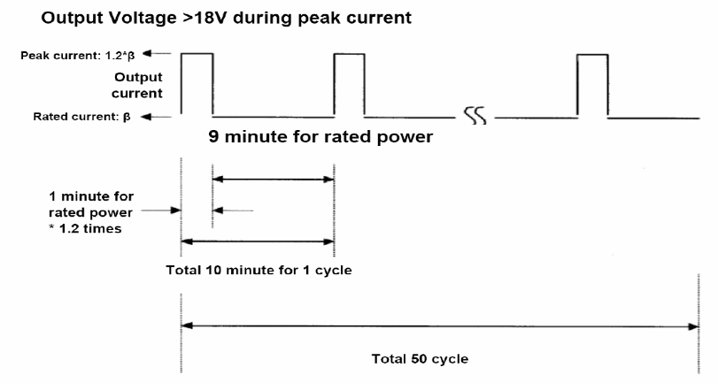

    - Load transient response
The adapter must within regulation when applied a step load from 0.05A to 100% load at 2.5A/us slew rate , 50% Duty cycle , Frequency be operated 100Hz and 100KHz in 25℃.
The output voltage will be performed 18.05V~20.5VV.
    - Protection
      - Over Voltage Protection
The output shall be protected to latch off at over-voltage condition maximum value can’t be over 27V
That might be return to normal state by AC reset.
      - Over Current Protection
The maximum constant current shall be more than 4.1A and be less than 5.4A at 90Vac and 264Vac. The adaptor shall be auto-recovery.
      - Short Circuit protection
Output can be shorted without damage. The adaptor shall be auto-recovery. (It will enter into normal condition when the fault condition is removed.)
      - Over Temperature Protection
No deformation and no discoloration on case and will be shut down. That will be return to normal state by ac reset.

- Environmental
  - Temperature
    - Operating
The AC Adapter shall be capable of operating at full load with an ambient temperature range of 0℃to +40℃.
    - Shipping/Storage
The AC Adapter shall be capable of withstanding ambient temperature from -30℃ to +80℃.
  - Humidity
    - Operating
The AC Adapter shall be capable of operation in relative humidity of 5% to 90% relative humidity, non-condensing.
    - Shipping/storage
The AC Adapter shall be capable of withstanding ambient relative humidity of 5% to 95% relative humidity, non-condensing.
  - Immunity
    - Lightning Surge Immunity
This is to follow the norm of IEC-1000-4-5 Level 3 requirements.
L-N +-1KV/1.2 * 50uS 5 times No function error.
L-FG, N-FG +-2KV/1.2 * 50uS 5 times No damage
    - Electric Fast Transients(EFT)
This is to follow the norm of IEC-1000-4-4/1995 (EN 61000-4-4) Level 3 requirements
  - Electrostatic Discharge (ESD)
This Adapter is capable to withstand ESD test voltage at any point around the enclosure as below.
±15KV air discharge performance criterion B.
±12KV air discharge performance criterion A.
±8KV contact discharge performance criterion A.
  - Surface Temperature rise
Ambient 25℃; input voltage 100Vac/240Vac case temperature rise≦40℃ with system loading (95%) on bakelite.
  - Dielectric Withstand Voltage (HI – POT)
Between AC input and secondary AC 3KV test time 1 minute; 100% of line products of this Adapter shall be applied 3000Vac for 2 seconds between AC input terminals and output terminals. Cut off current 3mA.
  - Leakage Current
Y cap no more than 220pF.
Leakage current no more than 20uA(max) at 240Vac/50Hz.for delta product line.
  - Insulation Resistance
The insulation resistance shall be not less than 30M ohms after application of 500Vdc/10mA for 1 minute.
  - Electromagnetic Interference (EMI)
The adapter shall comply with the following national standards.
- FCC Part 15.
- CISPR 22 Class B.
- The limits shall be meet with a margin more than 4dB with all system applicable.
  - MTBF
    - MTBF (Mean-Time-Between-Failures) Calculation
The calculated MTBF shall be 150,000 hours of continuous operation at 25℃, maximum load and 100Vac / 240Vac.
    - Electrolytic aluminum cap. Lifetime
The lifetime is least 13140 hours in Full load at 25℃at 100Vac/60Hz and 240Vac/50Hz.

  - Acoustic test
Input Condition: Vin: 90Vac / 264Vac
Load Condition: Dynamic Load follower ASUS Spec
Static Load (from 0A to Full Load , 0.1A pre step )
NB ADAPTER SPEC :
Static Load
WM Type : Microphone at a distance of 10cm from the surface and noise level is less than 20dB
Dynamic Load
WM Type : Microphone at a distance of 10cm from the surface and noise level is less than 25dB

- Mechanical
  - Outline Dimension: 63.0 * 63.0 * 28.5 mm, Color: Black
  - US PIN: ADP-65DW Y2E/Y2G/Y2L/Y2M/Y2R/YCA/Y2S/Y2T/Y2E5/Y2L5
CN PIN: ADP-65DW X2E/X2G/X2L/X2M/X2R/X2S/X2T/X2E5/X2L5
EU PIN: ADP-65DW Z2E/Z2G/Z2L/Z2M/ZZD/Z2R/ZBA/Z2S/Z2T/ZBB/ZBC
UK PIN: ADP-65DW WBA
AU PIN: ADP-65DW EBA
  - DC Cable Length: 2000 mm for all model, except ADP-65DW ZZD/ZBB/ZBC
DC Cable Length: 1800 mm for ADP-65DW ZZD/ZBB/ZBC
AD Cable Length: 2300 mm for ADP-65DW YCA/ZBA/WBA/EBA
  - DC Cable Type: UL1571 20AWG for all model, except ADP-65DW ZZD
DC Cable Type: UL1571 #18AWG for ADP-65DW ZZD/YCA/ZBA/WBA/EBA
DC Cable Type: UL11352 #18AWG for ADP-65DW ZBB/ZBC
  - DC Connector Dimension:
 | Item
Model Name | Outside Dimension (-) | Inside  Dimension (+) | ID Pin | Length
ADP-65DW  Y2E/X2E/Z2E/Y2L/X2L/Z2L/X2E/X2E5/X2L5 /Y2E5/Y2L5 | 5.5 | 2.5 | NA | 11.0
ADP-65DW Y2G/X2G/Z2G/Y2M/X2M/Z2M/X2S/Y2S/Z2S  /ZBB | 4.0 | 1.2 | NA | 9.8
ADP-65DW  YZ/ZZ/DZ/EZ/EZA/YCA/ZBA  /WBA/EBA | 2pin jack: CHENGSHUO 2PJ-005B
ADP-65DW  X2R/Y2R/Z2R/X2T/Y2T/Z2T/ZBB | 4.5 | 2.9 | 0.6 | 10.0
ADP-65DW  ZBC | 4.0 | 1.7 | N/A | 11.0
  - Adapter Weight: US/CN: 169.5g ±2.5%
EU: 178.1g ±2.5%
UK: TBD
AU: 205g ±2.5%

Mechanical characteristics
Item |  | Conditions | Specification
1. | Cord flexibility test  (Delta spec) | 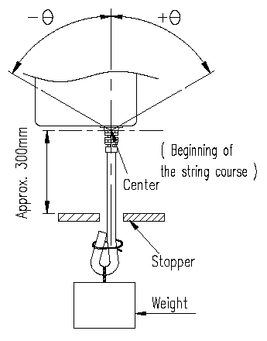  Hang the specified weight and swing it to one direction and return to the original position then swing to the opposite direction and return to the original position. This constitutes one cycle. The DC power supply shall be subjected to the specified cycles a specified speed.  - Weight: 200g  - Swing angle (θ): 0 ~ 180°  - Cycles: 1000,3000,10000cycles  - Speed: 40 cycles/min.  - Compliance: plug SR, case SR. | Disconnection rate of the wire shall be  1000 cycles –less 10%  3000 cycles – less 20%  10000 cycles – less 100% without damage to the insulations, etc..
2. | Cord flexibility test  (Customer Spec.) | Hang the specified weight and swing it to one direction and return to the original position then swing to the opposite direction and return to the original position. This constitutes one cycle. The DC power supply shall be subjected to the specified cycles a specified speed.  (If the cable is without core don’t need core SR test )  - Weight: 200g  - Swing angle (θ): 90°  - Cycles: 3000 cycles  - Speed: 40 cycles/min.  - Compliance: plug SR, case SR. | Disconnection rate of the wire shall be 30% or less for plug SR, core SR and 10% or less for case SR, without damage to the insulations, etc..
3. | Cord tensile test | 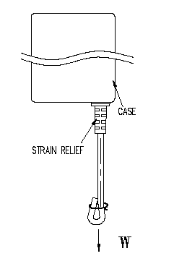  A static load shall be applied and sustained for a period. Excessive load shall not be applied in this test, unless special request.  Load (w): 10 kgf  Durance: 60 sec | Contact part and bushing shall not be detached.
4. | Vibration | Non-operating, Random vibration:  5~100 Hz 0.015 G2/Hz  100~137 Hz 6 dB/oct  137~350 Hz 0.008 G2/Hz  350~500 Hz -6 dB/oct  Acceleration: 2.09 Grms  Duration: 20 min.  Direction: X,Y,Z | - PSU must operate with specification after non-operation test.  - PSU shall be no mechanical damage after test.
5. | Shock | Non-operating  - Pulse: Half sine wave.  - Peak acceleration: 50 G  - Duration: 11 ms  - Number of shock: 1 shock per each direction, 6 directions. | - PSU must operate with specification after non-operation test.  - PSU shall be no mechanical damage after test.
6. | Drop test  (with outline label) | - Operating  - The drop height: H= 76 cm.  - The drop orientation: 6 face for each.  - Power on  - Non-operating  - Drop height: H= 110 cm.  - The drop orientation: 6 face for each.  - Low height drop  Drop TIMES: 130 times for every surface (six side), 780 times in total.  Test surface material : The concrete Drop height: 10cm  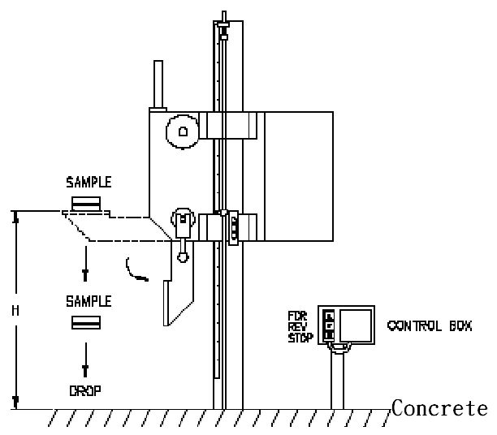  - Equipment: | - ATS function Pass.  - No PWB copper pad peeling and broken.  - No soldering crack.  - No component broken..  - Hi-pot test pass with specific condition.  - Test Finger can’t touch the Hazardous Voltage of the product.
7. | Ball impact  (with outline label) | - Steel ball: 0.54 kgf .  - Drop height: 30 cm.  - A horizontal surface of laminated wood of hardwood at least 13mm thick, mounted on two layers of plywood each 19mm to 20mm thick, all supported on a concrete floor.  - Impact location: Classify according to DUT’s dimension. LxWxH  L+W <150 B,D,F,H,I,K  150<L+W <200 A,C,D,E,G,H,I,J,K,L  200<L+W A,B,C,D,E,F,G,H,I,J,K,L  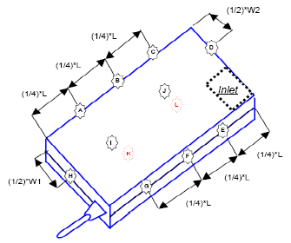  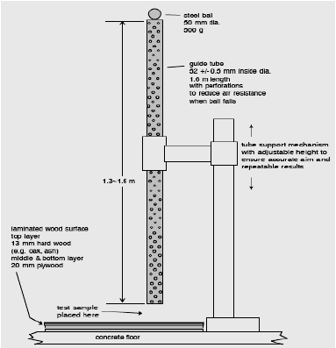  - Equipment: | - Hi-pot test pass with specific condition.  - Test Finger can’t touch the Hazardous Voltage of the product.
8. | AC Inlet Bending(I) | - Bending angle 15 °for either side.  - Bending speed 10 times per minute.  - Must withstand 30 times totally.  Equipment:  Arm controller: Delta.  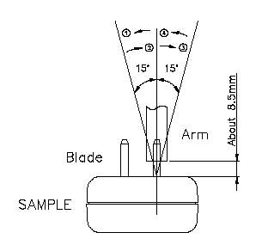 | - The blade can’t be any crack or damage.  - This test refers to JIS C8303 requirement.
9. | AC Inlet Bending(II) | - Bending angle 30 °for either side.  - Bending speed 10 times per minute.  - Must withstand 5 times totally.  Equipment:  Arm controller: Delta.  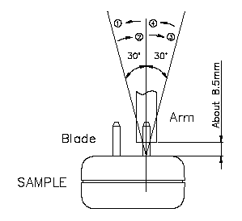 | - The blade can’t be any crack or damage.  - This test refers to JIS C8303 requirement.
10. | Push Force | Push one side blade to touch another side. The force must over 4.08kgf.  Equipment:  Push-Pull force measurement controller ( 50kgf )  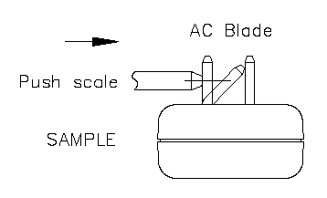 | No electrical or mechanical problem happened and no abnormity found in the shape.
11 | Load Weight | A static load 351b (15.9kg) / 2min for both pin to downside.  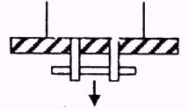  Equipment:  Load weight controller: Delta. | No electrical or mechanical problem happened and no abnormity found in the shape.
12. | Push Blade | Push both pin to inside that must withstand 20kgf / 1 min.  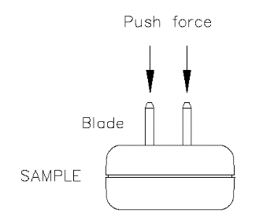  Equipment:  Push-pull force measurement controller ( 50kgf ) | No electrical or mechanical problem happened and no abnormity found in the shape
13. | Side Thrust | External enclosures are subjected to a steady force 250N±10N for a period of 5 sec.  Sample: 2pcs  Test point: feature of product end.  Equipment:  Push-Pull force measurement controller (0 ~ 50kgf).  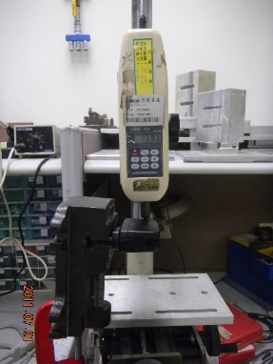 | At worst case condition, there are no damage on plastic case and socket and MUST keep the minimum safety distance 5.0mm
Product Applications: Notebook
Product Ingress protection(IP) rating: Not requirement(IP00)

